S3 uplods notification-

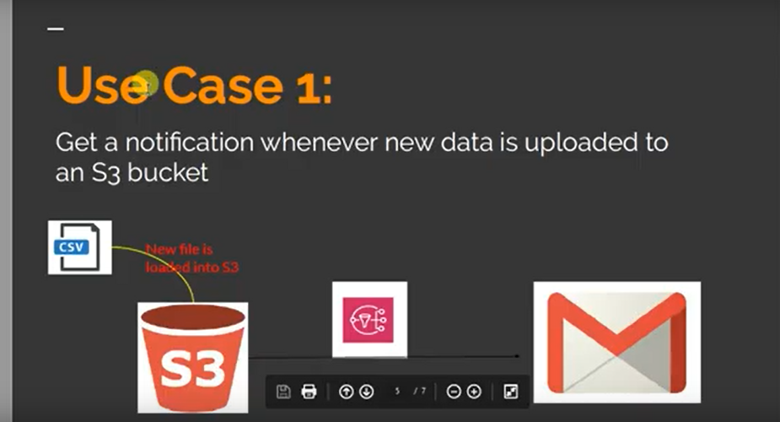

1. Create topic. Select everyone in access policy
2. Create subscription.
3. Subscribe topic.
4. S3 >> bucket >> properties >> event notification >> create event

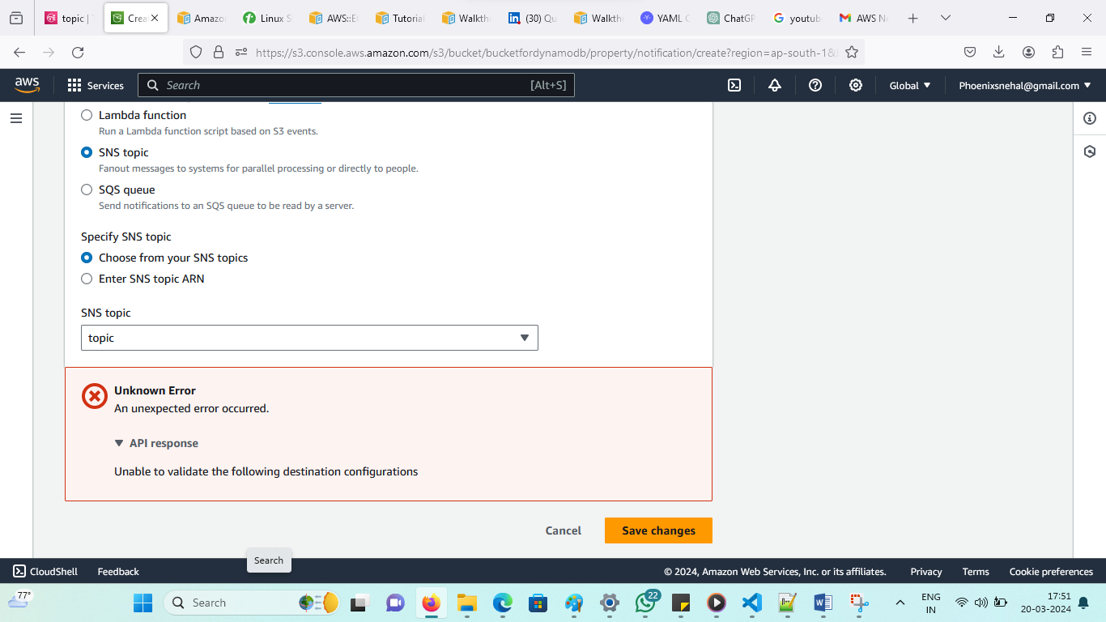

This means s3 bucket don’t have permission to go to sns topic while creating topic select everyone